Portfolio Docmuntation:
This is a portfolio web to help understand the user(mr.Huginn),and getting to know his experience in the web development and UI/UX design,And getting in Contact with him

Tools:
-HTML5(300 lines)
-CSS3(1674 lines)
-JavaScript(ES6+)(131 lines)

Github-Link:

Problems faced while coding:
-the ability to imagine how to code is structured
-making the website phone responsive
-trying to implement javascript into the website

Goals:
-to make a website that is responsive for all devices
-and o get to master frontend dev

Target user:
-Target user of is client from medium to small businesses that are in need of a way to publish or show off their existence to attract new clients.

Technical implements:

The dark/light mode:
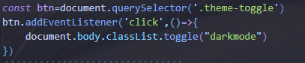
I used the querySelector to call the theme-toggle class
Which was given later an addEventListener which listened to the “click” that gave the ability to toggle the dark mode off/on the body

Hamurgur-menu
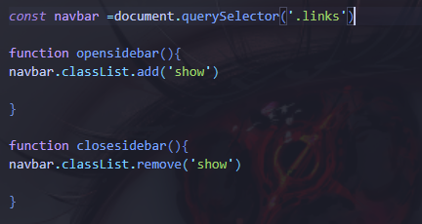
Im used the same way to call the links then made that when clicked
Its either removes or add the “show” which made the hamburger menu disappear or appear

Contact formulaire
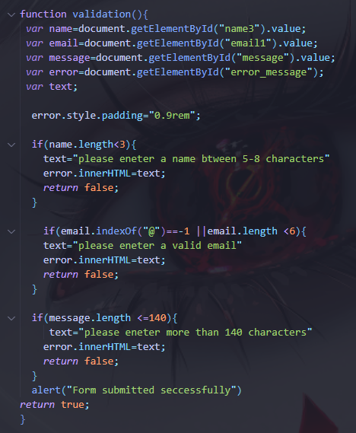
For the contact you need to call every needed element and give them ”.value”
Then using if statements we give a condition to each element and if not met we show an error message

Challenges:
Trying to make the website responsive to all devices was somewhat of a hassle

Solution:
Trying to use “@media” to make it work on all devices

Lesson:
The lesson I learned from this is I need to get working more on responsive designs

Future improvmement:
Adding the ability to save the chosen theme in the toggle section
And make it work more responsive to all devices

